CIS30A Lab 1: Writing Python Scripts using Variables, print(), input(), Built-in methods and Operators

In this lab, we will review Python installation procedures, using IDE and creating simple programs in Python. Refer to below lab instructions, complete the steps and answer questions to earn lab credits. Programming exercises require screen captures. Instructions for screen captures are as followed:
- Windows OS screen capture: Press Alt and Prt Sc buttons or use Snipping Tools, then paste image onto the document.
- macOS screen capture: See https://support.apple.com/en-us/HT201361
- Linux OS screen capture: Same as Windows OS. See https://itsfoss.com/take-screenshot-linux/

Exercise 1 Installing Python
- If you are using Windows PC, refer to installation guide in Part 1A.
- If you are using macOS, refer to installation guide in Part 1B.
- If you are using Linux, refer to Part 1C, installation section for Linux OS.
- If you have installed Python on your system, you can begin at Exercise 2 of this lab document.

Part 1A Installing Python on Windows
Refer to the below steps to install Python on your computer.

Windows 10:
- A. Visit Python Download page
- Select the appropriate link for Windows
- Once downloaded, open installer file and run the installation.
- Make sure you click on Add Python 3.x to PATH.
- To verify that your installation is successful, open Command Prompt (type cmd in Windows search bar), then input in command python --version then press Enter key. You should see Python version number displayed. *If you don’t see version number, step D was not completed appropriately. You will need to uninstall, restart your computer and repeat the above steps!
- After you installed Python, continue to Exercise 2- 18.

Part 1B: Installing Python in macOS
Python 2.x is shipped with macOS. We will NOT use Python 2.x in this course as it is no longer being supported. We will use version 3.8.x or later.
- A. Visit Python Download page
- Select the appropriate link for Mac OS X
- Once downloaded, go to Downloads and open installer package and run the installation.
- Agree to terms and conditions of license, click Agree.
- Click Install. Issue password if prompt.
- Click Add Python 3.x to PATH.
- After installation is successfully installed, open Terminal and type python -version then press Enter.
- You should see Python version number displayed.
- After you installed Python, continue to Exercise 2- 18.

Part 1C: Installing Python in Linux (Chrome, Debian, Ubuntu, Arch):
- Open Terminal and input the below commands, line by line. After each line, press Enter key.
$ sudo apt-get update
$ sudo apt-get install python3.9
If you’re using another version of Ubuntu (e.g. the latest LTS release) or you want to use a more current Python, you should be using the deadsnakes PPA to install Python 3.8:
$ sudo apt-get install software-properties-common
$ sudo add-apt-repository ppa:deadsnakes/ppa
$ sudo apt-get update
$ sudo apt-get install python3.9
If you are using other Linux distribution, chances are you already have Python 3 pre-installed as well. If not, use your distribution’s package manager. For example on Fedora, you would use dnf:
$ sudo dnf install python3
- After you installed Python, continue to Exercise 2- 18.

Exercise 2: Using IDLE to Display Text
Syntax: the set of rules which defines how a Python program will be written.
print( ) function: prints the specified message to the screen.

Example:

print( “Hello Kasey Nguyen!”)

“Hello Kasey Nguyen” is a string, text or group of sequential characters
This function takes different parameters = information that you input for so it can do a task.
You must use " " inside parameter () for string or text. You can also use single quotation mark ‘’ instead of double quotation marks inside print function parameter for string.

To do: Create a program that display your name.
- Open IDLE or another IDE.
- In Shell Click File, then New file to begin writing the program
- Refer to the above example use print( ) function to output your name
- Click Run. If prompt to save, click Yes and enter program name, such as Lab1Ex2.py
- Add another line using print() function to output your Full Name
- Save your program as FullName.py.
- Run the program. Take a screen capture for submission.
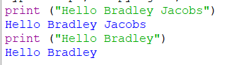

Exercise 3: Using Variables and print()
A few common data types:
- text: use string, example: "I am a student" or ‘I am a student’
- numbers: use integers (whole number, 50), float (decimal, 21.2), complex (1j)
- bool: use True or False keyword
Variable: is used to store data, a container with label for data, which is stored in program memory.
To declare a variable, you simply give it a name.
- Variable name can begin with upper or lower case letters and followed by numbers, and underscore ( _ )
Comment: readable explanation or annotation in the source code. Python interpreter will ignore the comments in the program.
- Single line comment: use #
- Multi-line comment: use 3 double or single quotation marks (“”” or ‘’’)

Example
myname = "Jane" #declare myname variable
myage = 25 #declare myage variable
print(myname) #display myname content
print(myage) # display myage content

In code block:
- We declare a variable, myname. We also assign it "Jane"
- We declare a variable, myage. We assign it 25, a whole number or integer.
- We use print() with variable within parameter to display content of each variable.

Task:
To do: Create a program to display your name, age, major using variables.

- Add comments about the program.
- Declare a variable for your name.
- Declare another variable for your age
- Declare a third variable for your major
- Use print( ) function to display your name, age and major.
- Take a screen capture of code and output.
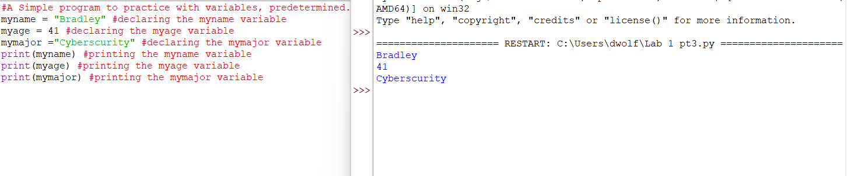

Exercise 4: input() and variables
input( ) function: lets you ask a user to enter or input text.
- Entered text can be stored into a variable that will be used later in the program.

Example:

user_name = input("Enter your name: ")
print(user_name)

- In the code block, we ask the user to enter his or her name.
- We first declare a variable to store the name, user_name, which will store the answer to the prompted question.
- Next, use print( ) function with variable, user_name, to display the name that was stored in the variable.

To do: Create a program that asks the user to enter name, age, height and weight using input(). Then use print() to display the information that was entered by the user.

- Use input( ) function and variable to ask the user to input name.
- Display the name that was input by the user
- Use input( ) function and a variable to ask the user to input age.
- Display the age that was input by the user
- Click Run, enter your name and age to test the program.
- Take screen capture of code and output.
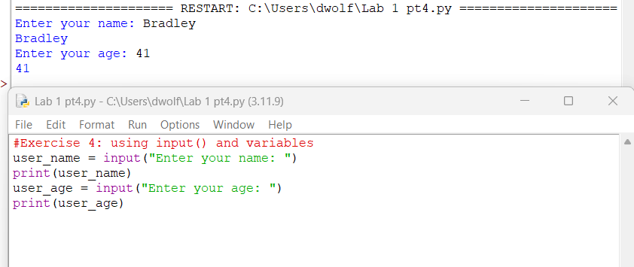

Exercise 5: Using Arithmetic Operator with Variables
Variables can be used to store input numbers

+ operator is used to add values
- operator is used to subtract values
/ operator is used to divide values
* operator is used to multiply values

Example:
num1 = int(input("Enter first number: "))
num2 = int(input("Enter second number: "))
print("Total is: ", num1+num2)

In the code block:
- num1 is the first variable, stores the first input number.
- num2 is the second variable, stores the second input number
- int is integer data type, or whole numbers. Input value is integer or whole number.
- print() is used to display the total = first input + second input

Task:
To do: Create a program that asks the user to enter 4 numbers, then display the sum and average of the numbers.

- Declare variables for user to input integers. Include input() in parameter.
- Use print() function to display the total of the 3 input numbers.
- Use print() function to display the average of the 3 input numbers
- Input values to test.
- Provide screen captures of code and output.
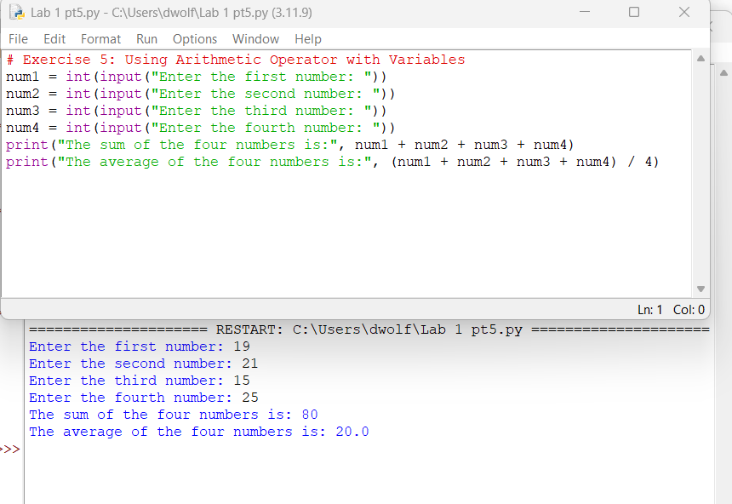

Exercise 6: Unit Conversion

Task:
1 mile = 1.60934 km
1 meter = 39.3701 inches
1 foot = 12 inches
Example:
distance = int(input("Enter the distance in miles: "))
conversion = 1.60934
print("Travelled distance is: ", distance * mile, “in km”)

In the code block:
- distance is the first variable, stores the number miles travelled.
- conv_km is the second variable is assigned 1.60934, which is the km value of 1 mile.
- int is integer data type, or whole numbers. Input value is integer or whole number.
- print() is used to display the distance travelled in km.

To do: Create a program that prompt user to input his or her height in feet and inches. Then, convert the height to meter.
- Declare variables for user input of height in feet and inches.
- Use print() to display the user height in meters.
- What is the data type of the output? Integer Why? Because you can only do calculations with integers, not strings.
- Take screen capture of code and output.
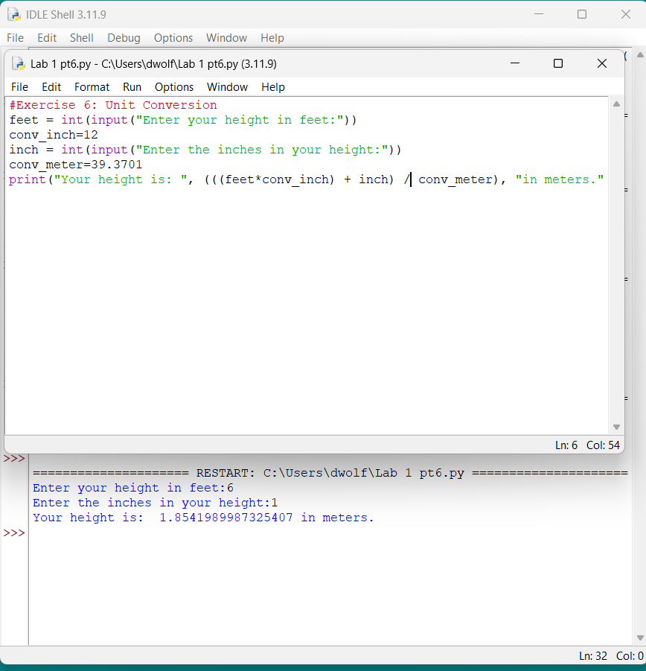

Exercise 7: Cloud Storage Cost using Variables and Operators

Task:
A cloud company charges clients $100 per month to store 750 GB of data. Each additional GB will cost the clients $5.
To do: Create a program that prompt the user to input the amount of data to be stored on cloud, then calculate the cost of cloud storage based on the input.
  - Create variable to prompt user to input data storage needs.
  - Use variables to store the additional data storage amount.
  - Use print() to display the cost of cloud storage.
  - Take screen capture of program code and output.
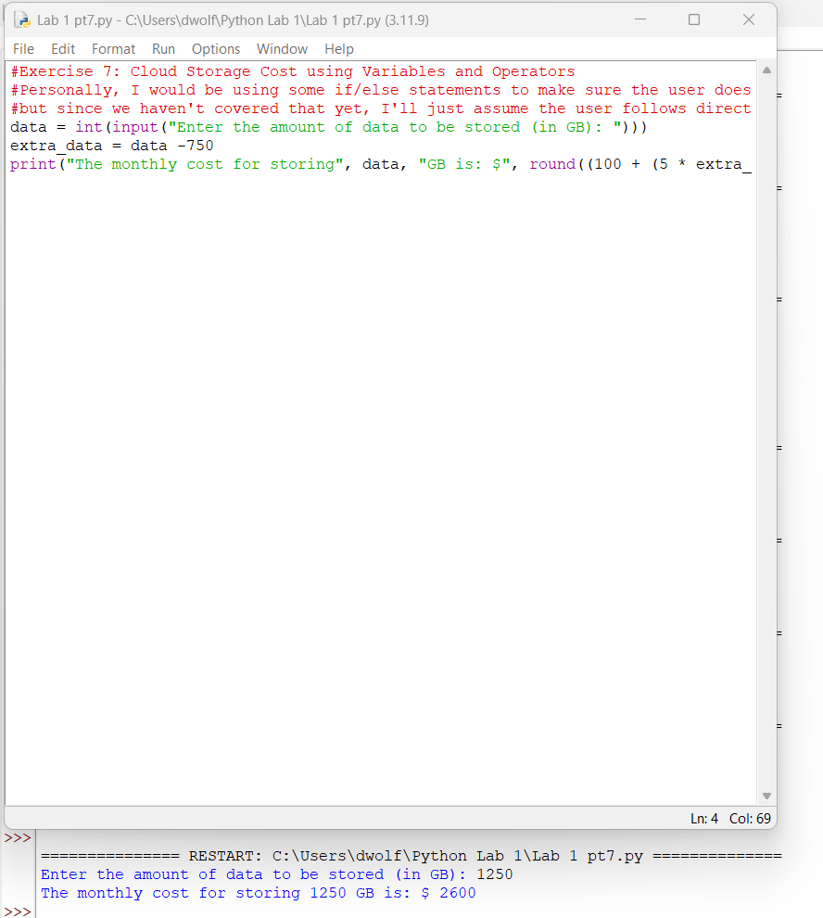

Exercise 8: Square-footage, Variables and Operators

Task:
Area of room = length x width.
Victoria wants to install new floor in 3 rooms with the following dimensions:
- Livingroom : length = 18 ft, width = 20 ft
- Master Bedroom: length = 15 ft, width = 12 ft
- Kitchen: length = 14 ft, width = 12 ft
The flooring company will charge Victoria $4.57 per square foot for floor installation.
To Do: Create a program that calculates the cost of these three rooms.
- Create variables for length and width of each room.
- Create variable for area of each room, calculate the area.
- Create a variable for total areas of 3 rooms; calculate the total areas of 3 rooms
- Use * operator to determine the cost of flooring; cost per square foot * total areas
- Use print() to show the cost of flooring.
- Take screen capture of code and output.
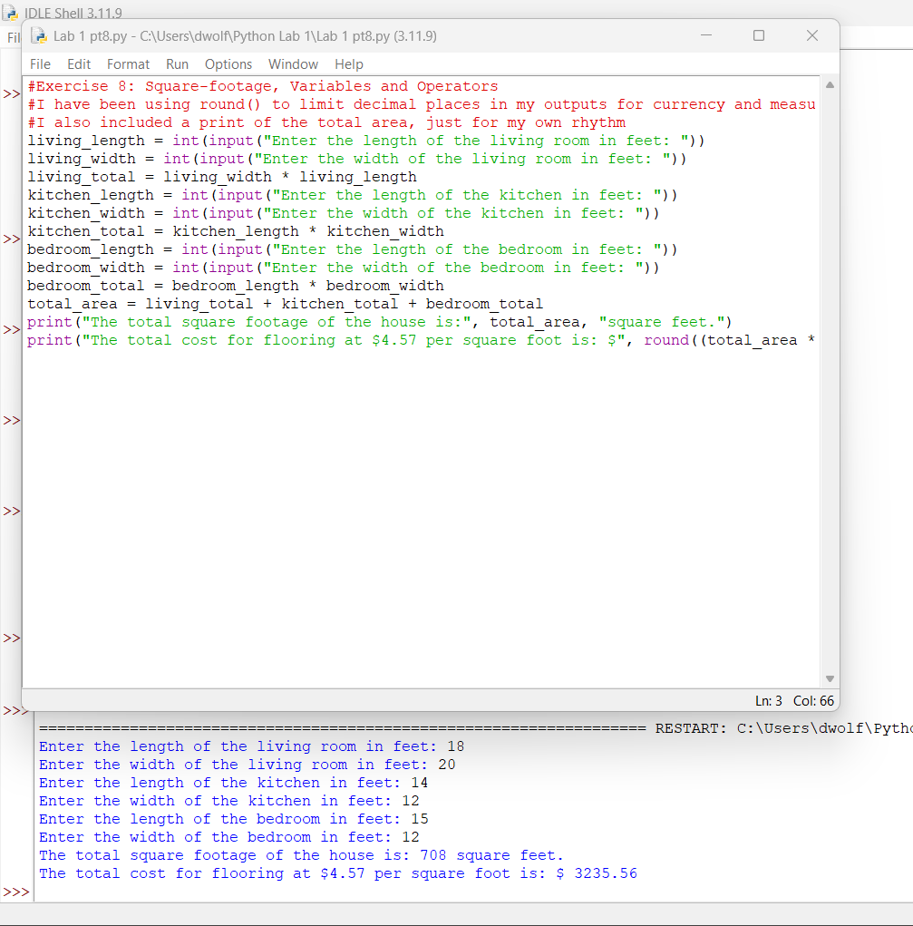

Exercise 9: Using Strings format, Variables to Determine Shipping
format(): method formats the given string into a desired output in Python. This method is often used with float data type.

- This method takes two types of parameters:
  - Positional parameters - list of parameters that can be accessed with index of parameter, {index}
  - Keyword parameters - list of parameters of type key=value, that can be accessed with key, {key}
- method returns the formatted string.

Index parameter in format()
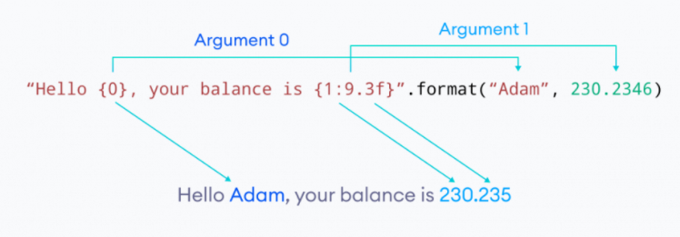
- Here, Argument 0 is a string "Adam" and Argument 1 is a floating number 230.2346.
- Note: Argument list starts from 0 in Python.
  - The string "Hello {0}, your balance is {1:9.3f}" is the template string. This contains the format codes for formatting.
  - The curly braces are just placeholders for the arguments to be placed. In the above example, {0} is placeholder for "Adam" and {1:9.3f} is placeholder for 230.2346.
  - Since the template string references format() arguments as {0} and {1}, the arguments are positional arguments. They both can also be referenced without the numbers as {} and Python internally converts them to numbers.
  - Since "Adam" is the 0th argument, it is placed in place of {0}. Since, {0} doesn't contain any other format codes, it doesn't perform any other operations.
  - However, it is not the case for 1st argument 230.2346. Here, {1:9.3f} places 230.2346 in its place and performs the operation 9.3f.
  - f specifies the format is dealing with a float number. If not correctly specified, it will give out an error.
  - The part before the "." (9) specifies the minimum width/padding the number (230.2346) can take. In this case, 230.2346 is allotted a minimum of 9 places including the ".".
  - If no alignment option is specified, it is aligned to the right of the remaining spaces. (For strings, it is aligned to the left.)
  - The part after the "." (3) truncates the decimal part (2346) up to the given number. In this case, 2346 is truncated after 3 places.
  - Remaining numbers (46) is rounded off outputting 235.

Key Parameter in format()
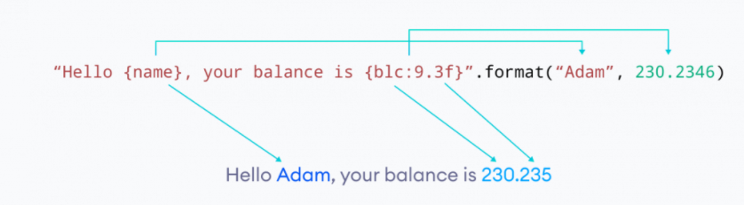
- Here, instead of just the parameters, we've used a key-value for the parameters. Namely, name="Adam" and blc=230.2346.
- Since these parameters are referenced by their keys as {name} and {blc:9.3f}, they are known as keyword or named arguments.
- The placeholder {name} is replaced by the value of name - "Adam". Since it doesn't contain any other format codes, "Adam" is placed.
- For the argument blc=230.2346, the placeholder {blc:9.3f} is replaced by the value 230.2346. But before replacing it, like previous example, it performs 9.3f operation on it.
- This outputs 230.235. The decimal part is truncated after 3 places and remaining digits are rounded off. Likewise, the total width is assigned 9 leaving two spaces to the left.

Task:
FastShipping company charges $2.66 per pound for ground shipment. Jack wants to ship the following items to his customers.
- Tablet: 1 lb
- Laptop: 7 lbs
- 55” TV: 37 lbs
How much will Jack spend on shipping these electronics?
Shipping cost = shipping rate * weight.
To Do: Write a Python program to calculate the total shipping cost for Jack.
  - Declare variables and assign weight values for the electronics.
  - Declare a variable for shipping rate.
  - Use * operator to calculate the shipping cost for each electronic.
  - Declare a variable for total shipping cost, use + operator to calculate the total shipping cost of 3 electronics.
  - Use print() to display the total shipping cost.
  - Take screen capture of program code and output.
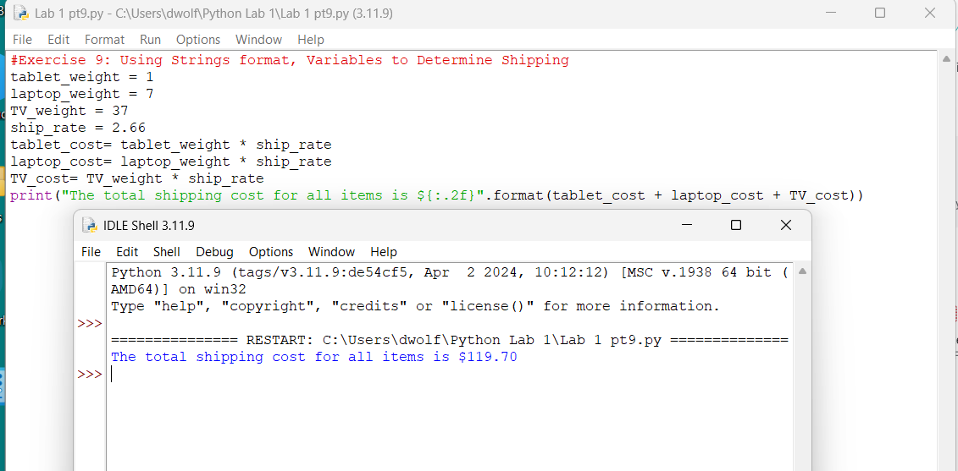

Exercise 10: Using abs()
- abs(): returns absolute value of the number
  - Example:
myVariable = -4
abs(myVariable)
output: 4
To-do: Write a Python program that returns the absolute value of -288.
Provide screen capture of script and output.
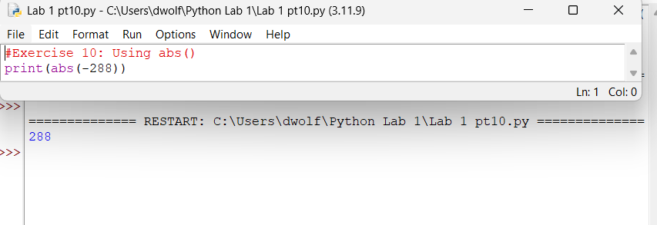

*Exercise 11: Using ceil() and floor() in Python Math module
- ceil(): returns the ceiling value of the number
  - Example:
import math #import math library
myvar = 3.56
print (math.ceil(myvar))
output: 4
- floor(): returns the floor value of the number
  - Example:
import math
fruit_price = 4.56
print(math.floor(fruit_price))
output: 4
To-Do: Juan weighs 187.13 lbs. Write a Python program that display Juan’s approximate weight in pounds using ceil() and floor(). Provide screen capture of script and output.
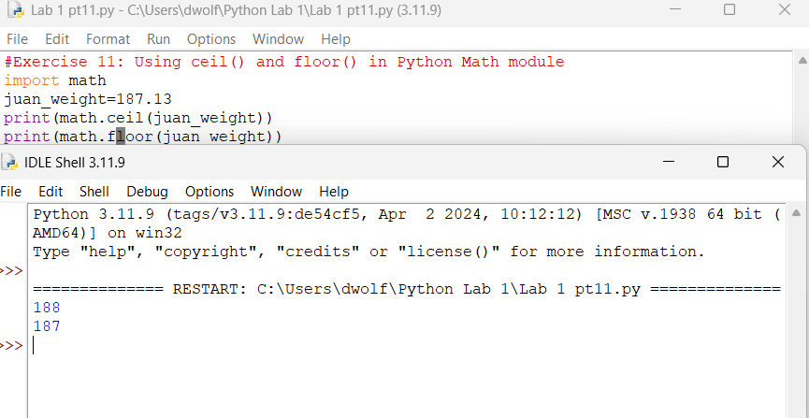

Exercise 12: Using min() and max() in Python
- max(): returns the largest value in the set of numbers
  - Example:
myList = [10, 50, 20, 80, 30]
highest_value = max(myList)
print(highest_value)
output: 80
- min(): returns the smallest value in the set of numbers
  - Example:
num_list = [3, 5, 9, 11, 2, 4]
lowest_value = min(num_list)
print(lowest_value)
output: 2
To-Do: Leila receives the following scores in on her math quizzes: 90, 78, 82, 61, 87, 94. Write a Python program that display the lowest and highest quiz scores. Provide screen capture of script and output.
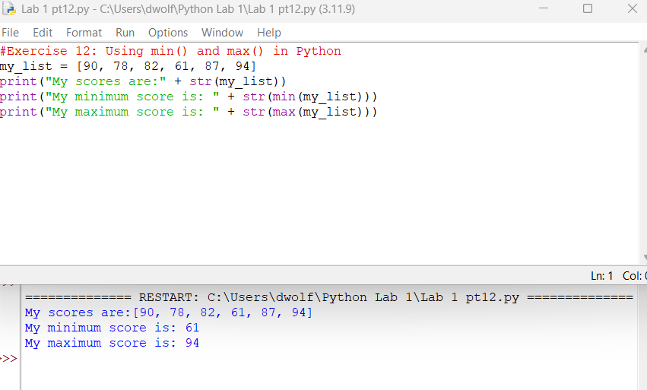

Exercise 13: Using sum() to find total
- sum(): adds the items of an iterable and returns the sum.
  - sum(iterable, start)
  - The sum() function adds start and items of the given iterable from left to right.
  - Example:
val = [1, 2, 6, 3, 4]
print(sum(val)) #1+2+6+3+4
print(sum(val, 9)) #9+1+2+6+3+4
output:
16
25
To-Do: Sonya ran 2 miles on Monday, 3 miles on Tuesday, 5 miles on Wednesday and 8 miles on Thursday.
- Write a Python program that display the total miles that Sonya ran using sum(). Provide screen capture of script and output.
- In the previous week, Sonya ran 10 miles. Edit the program to calculate and display the total miles Sonya ran in 2 weeks using sum(). Provide screen capture of script and output.
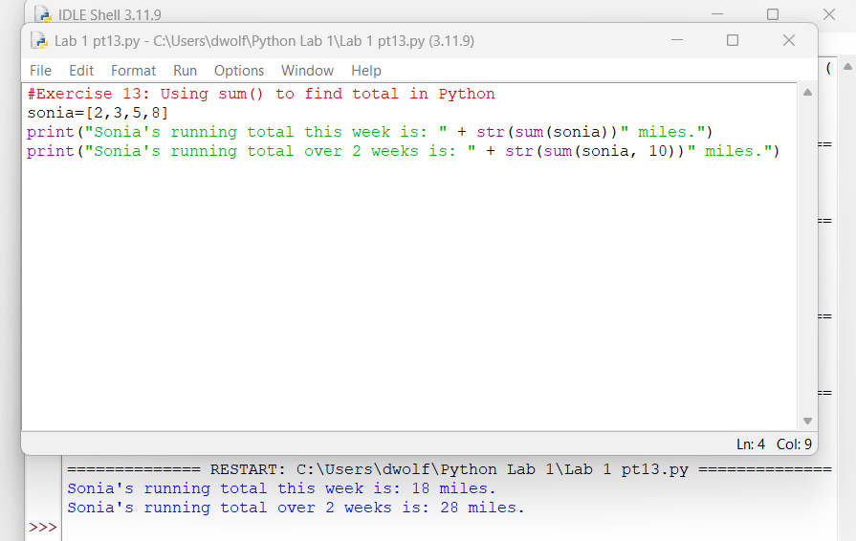

Exercise 14: Using pow()
- pow(x,y): returns the power of x to y, x is the base, the exponent
  - pow(x, y) is equal to x^{y}
  - Example:
print(pow(3, 2)) #3^2
output: 9
- pow(x, y, z) is equal to x^{y} % z
  - Example:
print(pow(4, 2, 3)) #4^2 mod 3
output: 1
To-Do: Write a Python program using pow() to calculate and display the results for the following:
- 6³
- -254⁵
- -12⁻⁸
- 5³ % 4
- 11⁶ % 8
Provide screen capture of script and output.
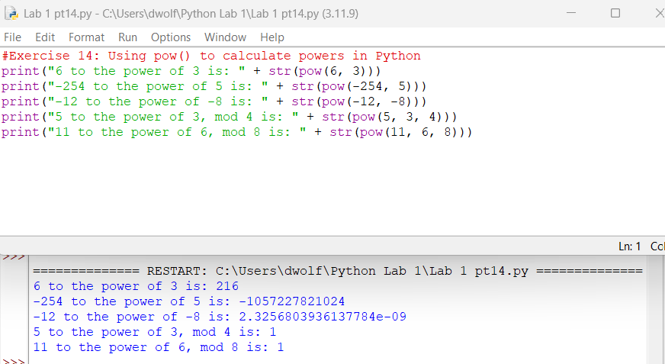

Exercise 15: Square-root in Python
- sqrt(): returns square root of a number
  - Example:
import math
print(math.sqrt(81))
output: 9
To-Do: Write a Python program that displays the results for the following:
- √100
- √560
- √8821
Provide screen capture of script and output.
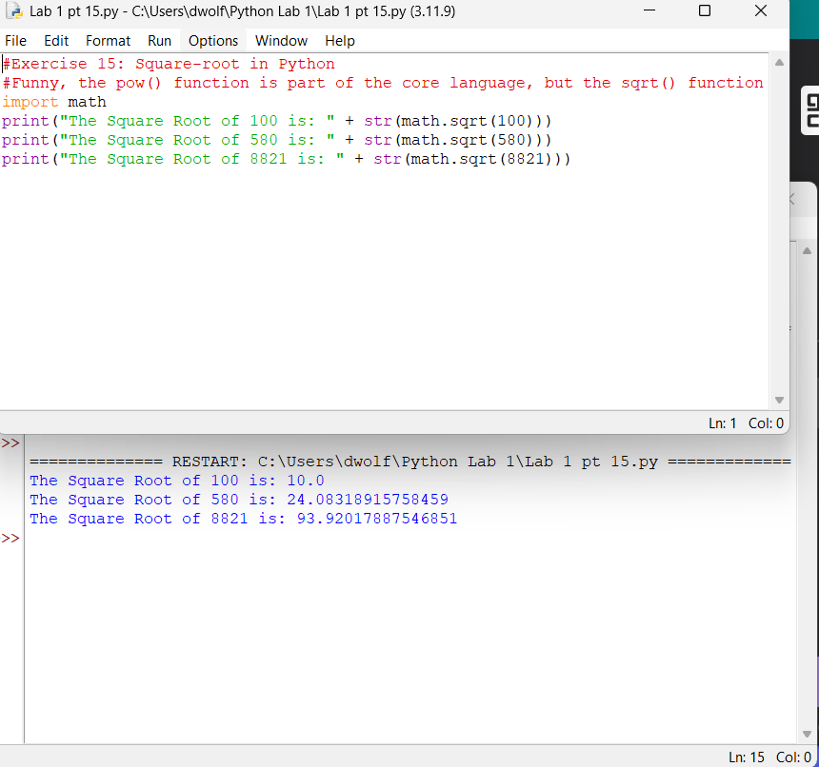

- randint(): built-in function of random module in Python 3 to return a random integer in range [start, end] including the end points.
  - randint(start, end)
  - Example:
import random
# a given positive range
r1 = random.randint(0, 10)
print("Random number between 0 and 10 is % s" % (r1))

# Generates a random number between
# two given negative range
r2 = random.randint(-10, -1)
print("Random number between -10 and -1 is % d" % (r2))

# Generates a random number between
# a positive and a negative range
r3 = random.randint(-5, 5)
print("Random number between -5 and 5 is % d" % (r3))
To-Do: Write a Python program that contains randint() to generate a random number between 0 – 100. Provide screen capture of script and output.
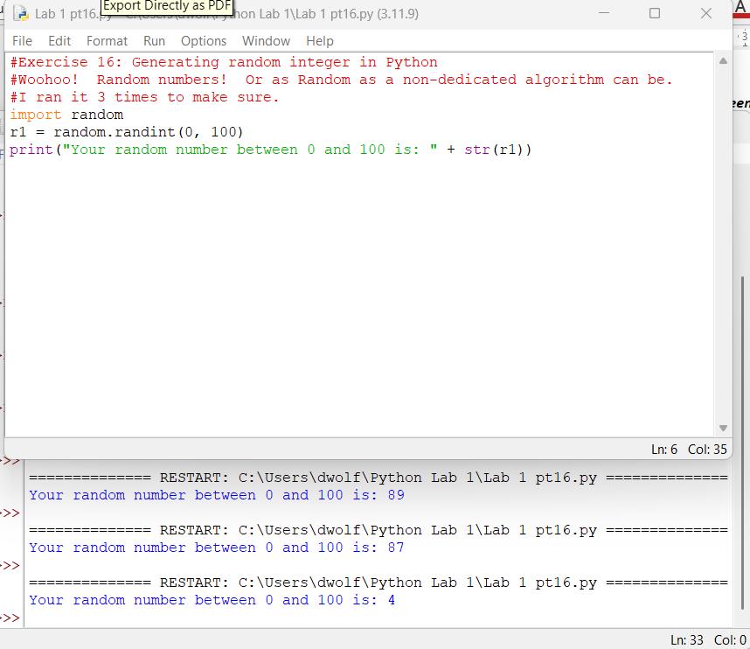

Exercise 17: Generating random integer in range with increment
- randrange(): returns a randomly selected element from range(start, stop, step).
    - start − Start point of the range. This would be included in the range.
    - stop − Stop point of the range. This would be excluded from the range.
    - step − An integer specifying the incrementation. Default 1
  - randrange ([start,] stop [,step])
  - Example:
import random

# Select an even number in 100 <= number < 1000
print "randrange(100, 1000, 2) : ", random.randrange(100, 1000, 2)

# Select another number in 100 <= number < 1000
print "randrange(100, 1000, 3) : ", random.randrange(100, 1000, 3)

Output:
Random number from 0-100 is : 26
Random number from 50-100 is : 58
To-Do: Write a Python program that contains randrange() to generate a random number between -100 to 100, stepping 10. Provide screen capture of script and output.
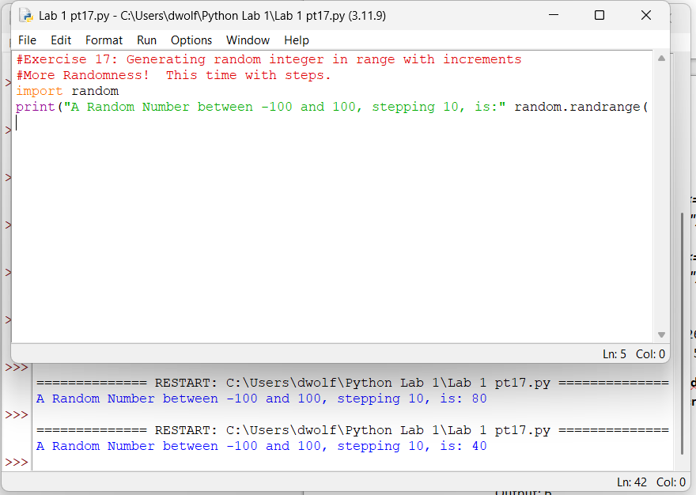

Exercise 18: Using Arithmetic Operators
- Addition operator (+): add values
  - 2+4
Output: 6
- Subtraction operator (-): subtract values
  - 8 – 2
Output: 6
- Multiplication operator (*): multiply values
  - 3*2
Output: 6
- Division operator (/): divide values
  - 12/2
Output: 6
To-Do: Kevin receives the following scores on his assignments: 100, 96, 80, 77, 62. Write a Python program that includes arithmetic operators to calculate and display Kevin’s average scores on the assignments. Provide screen capture of script and output.
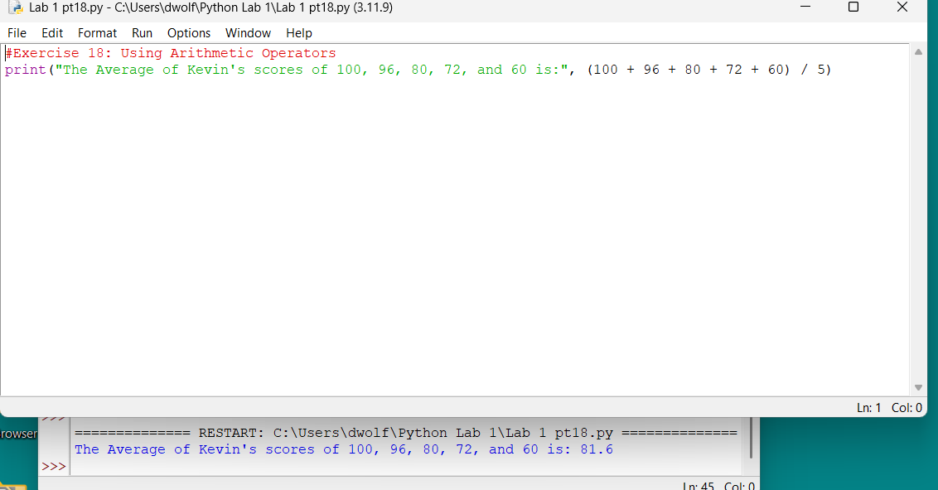

Exercise 19: Assignment Operators
Operator | Example | Equivalent to
= | x = 5 | x = 5
+= | x += 5 | x = x + 5
-= | x -= 5 | x = x - 5
*= | x *= 5 | x = x * 5
/= | x /= 5 | x = x / 5
%= | x %= 5 | x = x % 5
//= | x //= 5 | x = x // 5
**= | x **= 5 | x = x ** 5
&= | x &= 5 | x = x & 5
|= | x |= 5 | x = x | 5
^= | x ^= 5 | x = x ^ 5
>>= | x >>= 5 | x = x >> 5
<<= | x <<= 5 | x = x << 5

To-Do: Coffee4Less.com sells gourmet coffee beans at $10.00 per lb. The store offers 10% discount to all customers. Lisa purchased 23 pounds of coffee. Write a Python program that determines the discount and the total amount of Lisa’s purchase. Program must contain compound operator and appropriate messages displaying about discount and purchase total. Provide screen capture of script and output.
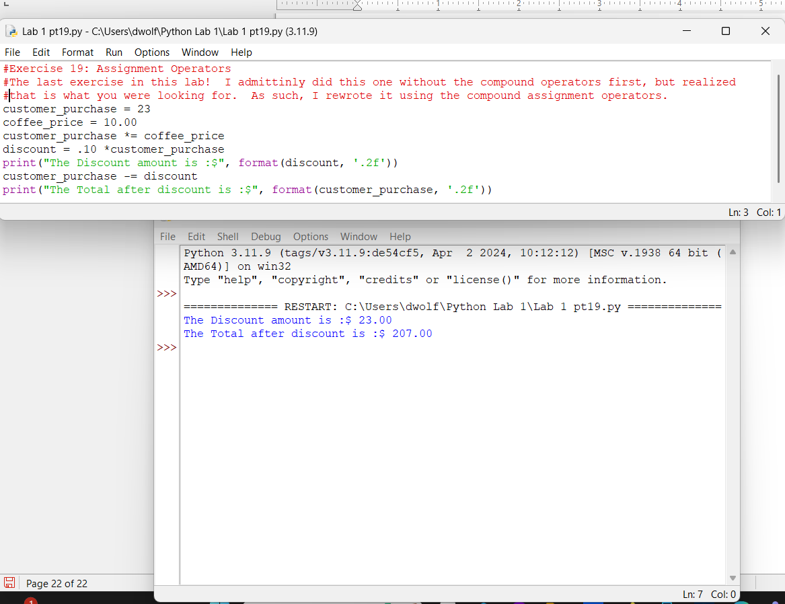

Login to Canvas and submit a document (.docx or .pdf) that contains screen captures of the lab exercises.

